saturday  10th September 2022  Community Litter pick  Time:  10am to 12noon  MEET AT  The Mornington Road side of Britannia Bridge, Bingley  Let’s have a greener, cleaner Bingley!  Other litter pick dates:  Saturday 22nd October  Sunday 13th November | BINGLEY NEEDS YOU!  ────  Litter pickers and hi-viz jackets provided  ────  A chance to meet new people  ────  Children are very welcome!  ────  Help improve YOUR neighbourhood  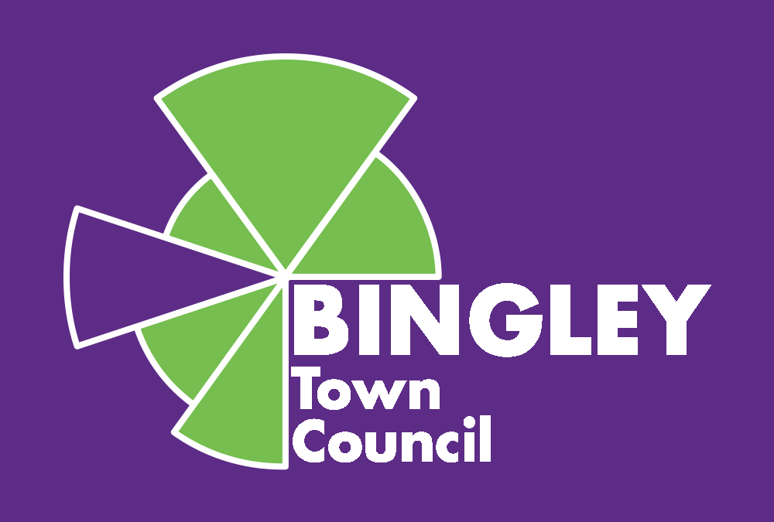  Contact: Cllr John Goode  07703 456792  www.bingleytowncouncil.gov.uk

