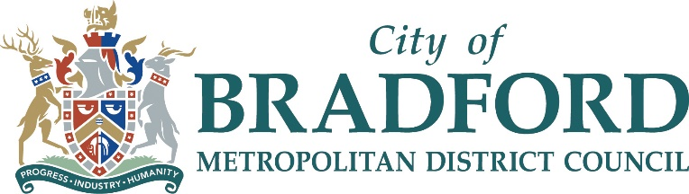

Bradford Council – Household Support Fund 2021-22

Voluntary and Community Sector
Guidelines Document

Grant size: Up to £6,000 (£2,000 for week 1 of Christmas holidays, £2,000 for week 2 of Christmas holidays and £2,000 for half term week in February)
Location: Across Bradford District
Submission Deadline: 5th November 2021
Where to send completed submission forms:
HAFGrant@bradford.gov.uk
Please note this grant is not related to HAF
Background
Bradford has one of the highest rates of child poverty in the country with more than 30,000 children living in poverty. We know that returning to school in poor physical and mental condition can have a detrimental impact on children’s mental and physical wellbeing, as well as their educational attainment.
What is the Household Support Fund?
- The Department for Work and Pensions (DWP) is providing funding to support those most in need this winter during the final stages of the economic recovery. The funding is available from October 2021 to March 2022.
- This application will provide assistance to vulnerable families with children and other vulnerable households, primarily to support them with food and fuel
- Each food parcel will need to support an individual or a family with children for a week.

Funding opportunity
- This funding will provide grants of up to £6,000 to support organisations who will deliver the Household Support Fund. We are looking to fund projects that address food poverty in Bradford, through food provision for vulnerable individuals and vulnerable families with children.
Criteria
- The grant can be used to introduce a new food provision or extend a current food provision.
- This grant covers food provision predominantly for the two weeks of Christmas and 1 week of the February Half Term holiday period.
- We would be looking for the following standards as a minimum:
  - Food: Provision of food must comply to food hygiene standards from purchase, preparation and delivery to families. The nutritional value of food must be prioritised.
  - All health and safety measures (including Covid Safety measures) to be implemented.
- All submission forms must be fully completed and signed.
- If successful with the award, 90% of the total amount awarded will be paid prior to delivery for set up and the other 10% will be paid at the end of the scheme (post-delivery) subject to relevant data submission by the delivery organisation, who will not use the funds for any other purpose.
- A grant agreement will be issued.
Timeline
The deadline for applying for this grant is 5th November 2021.
Process
To apply, please complete the application form accompanying these guidelines and return to HAFGrant@bradford.gov.uk by the date given above .
If you have any queries concerning the form, please contact Charlie Jerram by email Charlie.Jerram@bradford.gov.uk or telephone: 07811505658.

